Pre-Submission Readiness Checklist

A full-fidelity FDA regulatory assessment and the Q-Submission (Pre-Submission) that follows—hinges on receiving a precise, device specific data set from your team. The checklist that accompanies this letter identifies every critical input we need to:
- Classify the device under the correct 21 CFR regulation, product code, and class.
- Select sound predicates or justify a De Novo/PMA pathway.
- Build the test matrix (bench, biocompatibility, software, usability, and clinical).
- Document submission risks and mitigations (internally for investor benefit)
- Draft focused questions that maximise the value of the Pre-Submission meeting.

Checklist
Indications & Intended Use:
- Exactly which clinical conditions, signs, or symptoms will the device detect / diagnose / triage / monitor?
- Are outputs diagnostic, screening, risk-stratification, or billing support only?
- Single-patient use, multiple-patient use, or system infrastructure?
- Acute vs. chronic conditions; emergent vs. elective use.
- Does the device replace or augment a standard of care procedure? (If so, name it.)
Patient Population & Contraindications:
- Target age range, sex, weight/BMI limits, comorbidities.
- Special populations (pregnant, immunocompromised, pediatrics, geriatrics, non-English speakers).
- Known contraindications or exclusion criteria.
- Environment of use (hospital ED, retail clinic, rural kiosk, home).
Clinical Users & Workflow Integration:
- Primary operator (patient, nurse, MA, remote physician, billing staff).
- Required user qualifications or certifications.
- Training time and medium (onscreen tutorial, LMS, in-person).
- Where in the care pathway does the device hand off to a human?
Technology & Data Inputs:
- Sensor suite (e.g., mmWave radar HR/RR, optical SpO₂, IR temp, load-cell weight).
- Non-sensor inputs (structured questionnaires, ID scan, EHR pull).
- Third-party devices or peripherals relied upon (BP cuff make/model, cameras).
- Data sampling rate, accuracy specs, and calibration method for each sensor.

Algorithm / Software Architecture:
- Type of algorithm (rule-based, classical ML, deep learning).
- Training data sets (size, demographics, source, preprocessing).
- Update cadence and version-control approach (static, continuous learning, PCCP).
- Explainability features provided to clinicians (feature importance, saliency maps).
Outputs & Clinical Actions:
- Output format (ESI level, ICD-10 list, CPT suggestions, vitals trend graph).
- Whether any automated actions are taken (claim submission, alert routing).
- How outputs are displayed, printed, or exported (PDF, HL7, FHIR).
Hardware Characteristics:
- Dimensions/weight, mobility (casters, wall-mount).
- Power requirements, battery backup, operating temperature/humidity.
- Materials in patient-contact areas (for biocompatibility).
- Service life and end-of-life disposal plan.
Connectivity & Cybersecurity:
- Wired, Wi-Fi, cellular, or Bluetooth?
- Data-at-rest / data-in-transit encryption specs (AES-256, TLS 1.3).
- User authentication (SSO, multifactor).
- Compliance standards targeted (HIPAA, NIST 800-53, ISO 27001).
Interoperability:
- Supported standards (HL7 v2.x, FHIR R4, DICOM).
- EHR vendors validated.
- API documentation availability and version.
Performance & Validation Testing:
- Bench testing completed or planned for each sensor/algorithm.
- Human factors/usability studies (IEC 62366 scope, sample size).
- Clinical validation study design (prospective vs. retrospective, endpoints).
- Stress, drop, ingress-protection, and electrical safety testing (IEC 60601-1/-1-2).
Labeling & User Documentation:
- Draft Intended Use / Indications for Use statement.
- Quick-start guide, operator manual, and on-device prompts.
- Contraindication and warning language.

Service, Maintenance & Updates:
- Preventive maintenance schedule, calibration intervals.
- Field-upgrade process (firmware OTA, recall simulation).
- Spare parts availability and MTTR (mean time to repair).
Data Management & Retention:
- Duration of data storage per encounter.
- Patient access method for their own data.
- De-identification or anonymization workflow for secondary uses.

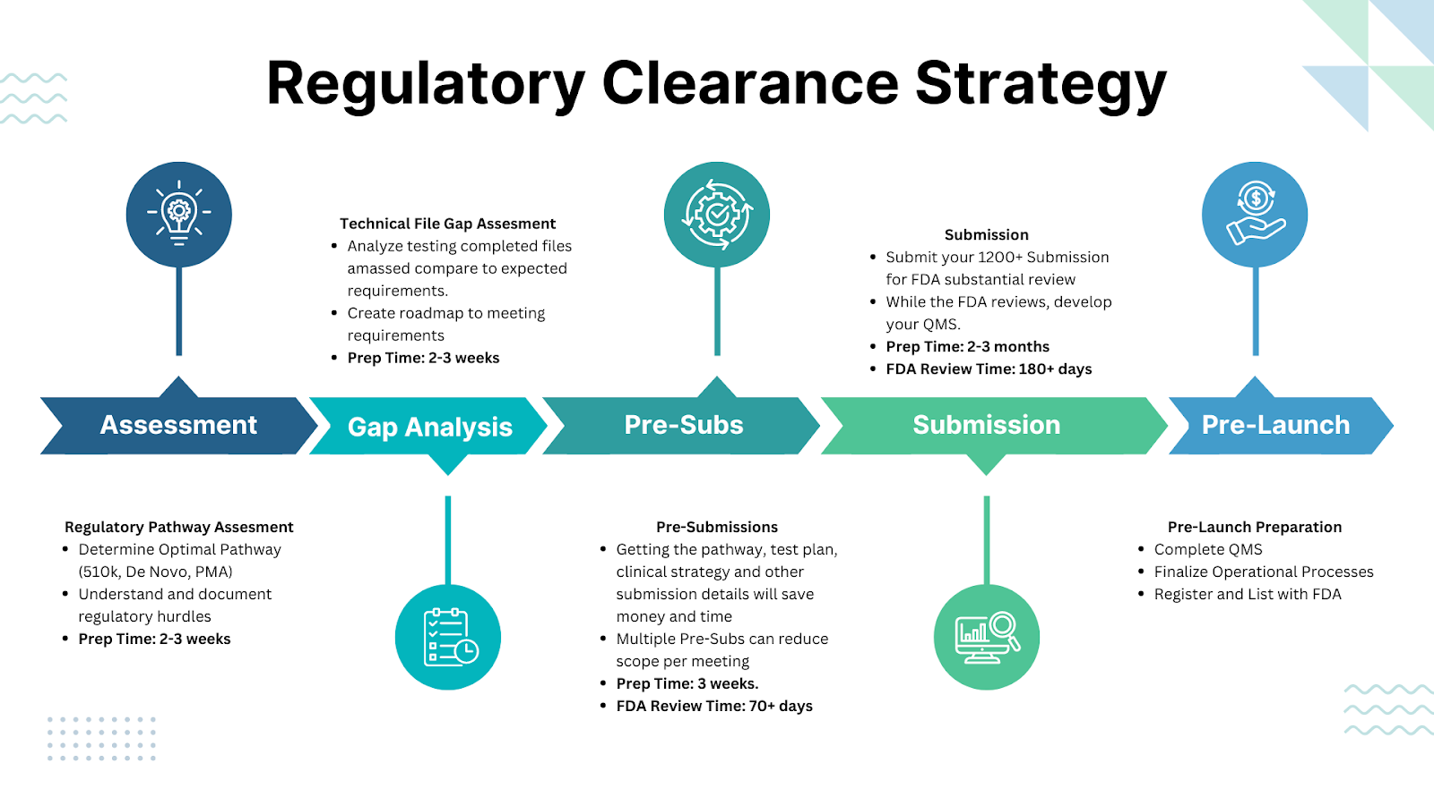
Figure 1. US FDA Regulatory Clearance Process

